Project Design Phase-II
Data Flow Diagram & User Stories
Date | 27 February 2026
Team ID | LTVIP2026TMIDS78907
Project Name | Optimizing user, group and role management with access control and workflows
Maximum Marks | 4 Marks

Data Flow Diagrams:
A Data Flow Diagram (DFD) is a traditional visual representation of the information flows within a system. A neat and clear DFD can depict the right amount of the system requirement graphically. It shows how data enters and leaves the system, what changes the information, and where data is stored.
Example: (Simplified)
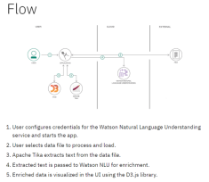
User Stories:
User stories were developed to capture requirements from the perspective of different stakeholders. These stories help translate technical needs into real user expectations.
Sample user stories include:
• As a System Administrator, I want to create and manage users so that I can control system access efficiently. • As an End User, I want to request access to resources so that I can perform my job tasks without delay. • As a Manager, I want to approve or reject access requests so that security policies are enforced. • As an IT Security Officer, I want to view audit logs so that I can monitor suspicious activities.
• As an Administrator, I want role-based permission assignment so that manual errors are reduced.

